TEST CASE

Full name: Hoang Thuy nguyen

DE191056

CONTENT 1:

Case1:

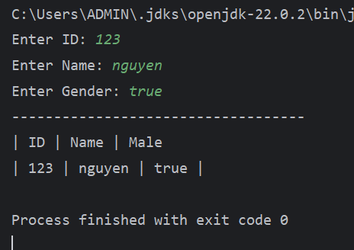

Case 2:

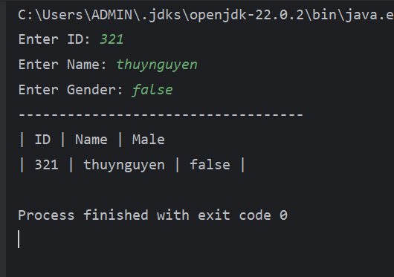

CONTENT 2:

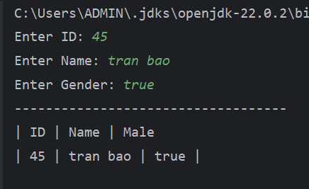

CONTENT 3:

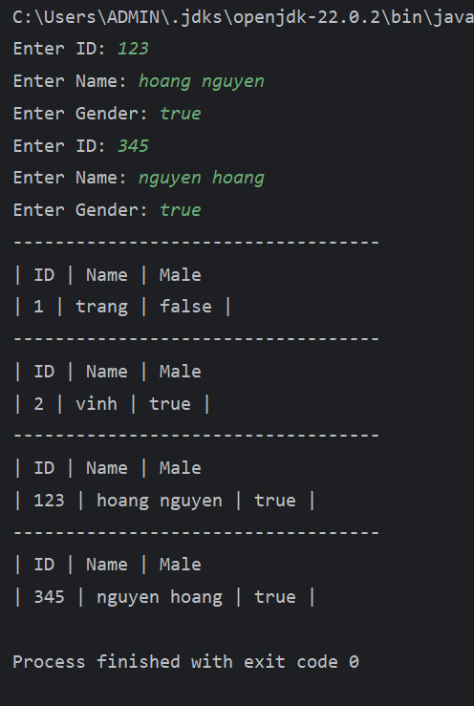

CONTENT 4:

